**Come enjoy a Pie Social at Balkan Community Center, 6061 HWY 73, Chisholm, MN**

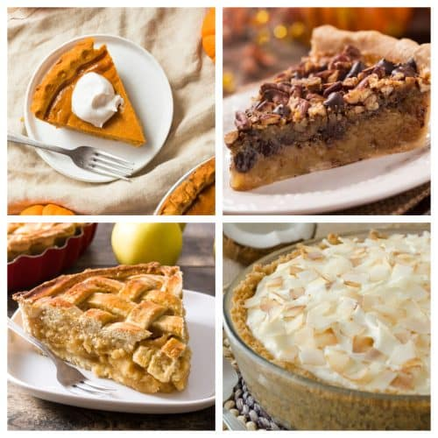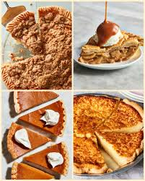

* **January 28th, 2023 1-3 PM**
* **February 18th, 2023 1-3 PM**
* **March 18th, 2023 1-3 PM**

**A slice of pie with ice cream and coffee or water will be $5!**

**Come for the fellowship!**

**Pies will be purchased from the Village Inn in Virginia.**